HEATING AND COOLING TEST 2009

Name: ___________________________________________ (35 marks)

- Non-physics people often use the word heat when then actually mean temperature or even internal energy (thermal energy) of the object. Explain the difference between the three (words in italics).
(3 marks)
There are various definitions for heat so you use the one you have taught e.g.
- Heat is the transfer of energy from one object to another caused by a difference in temperature.
- Heat is the transfer of energy from an object at a higher temperature to one at a lower temperature until thermal equilibrium is reached.

- Temperature is a measure of the average kinetic energy of an object.
- Thermal or Internal energy is the sum of the kinetic and potential energy of an object.

- Explain why supermarket freezers still manage to keep the contents frozen despite often having no lids. (3 marks)

This is due to convection. Heat is removed from the air surrounding the food in the freezer making the air more dense and cold. Any warm air rises (less dense) and is replaced by the colder, denser air. Cold air through convection keeps the food frozen.

- People in hot arid regions frequently store water in porous canvas bags through which some of the water can seep. What is the purpose of doing this and how is the purpose achieved? (3 marks)

The purpose is to keep the water cool.
When the water seeps through onto the outside of the bag, the water starts to evaporate.
Evaporation is a phase change and needs energy (latent heat).
The energy to change phase is taken from the bag and hence the water in the bag so the water cools.

- Explain, with examples, the difference between a high grade energy forms and a low grade energy form. (3 marks)

Use the definitions you have taught although the following are possible definitions:
High grade energy form is one that transforms with a high efficiency for example, electrical energy being used to produce heat energy.

Low grade energy form is one that transforms with a low efficiency for example, thermal energy being used to produce mechanical energy.

- What is the specific heat of an alloy if it requires 3.20 x 10⁴ J of energy to heat 1.20 kg of the alloy from 15.0 ⁰C to 92.5 ⁰C? (2 marks)

Q = mcΔT
3.20 x 10⁴ = 1.20 x c x (92.5 – 15)
3.20 x 10⁴ = 93.0 c
c = 344 J kg⁻¹ K⁻¹

- A laboratory technician was trying to find the latent heat of fusion of an alloy she had created. She found that she needed to add 6.84 x 10⁵ J of energy to 1.95 kg of the alloy to fully melt it without changing the temperature. Find the latent heat of fusion of the alloy. (2 marks)

Q = mL
6.84 x 10⁵ = 1.95 x L
L = 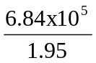

L = 3.51 x10⁵ J kg⁻¹

- A small espresso coffee machine contains 0.500 kg of water at 20.0⁰ C. How much energy is required to change the water into steam at 100.0⁰ C? (3 marks)

Q = heat water + boil water away
= mcΔT + mL
= (0.5 x 4180 x 80) + (0.5 x 2.26 x 10⁶)
= 167200 + 1130000
Q = 1297200
Q = 1.30 x 10⁶ J

- A large 3.50 x 10³ W kettle uses 1.946 x 10⁶ J to completely boil away the contents of a kettle. Calculate the time (in minutes) that it would take for this to occur. (3 marks)

P = 3500 W
P = 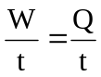 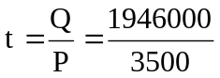
t =  = 556 s
= 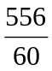
t = 9.27 minutes

- Alan wants to add the exact amount of ice to his 250.0 mL drink (specific heat 3.99 x 10³ J kg⁻¹ K⁻¹) to cool it from 36.0⁰C to 7.00⁰C. The ice comes from the freezer where it is kept at a temperature of -6.00⁰C. Assuming the cup used is fully insulated, how much ice must he add? (3 marks)

Heat lost = heat gained
Drink cools = heat ice + melt ice + heat water from ice
mcΔT = mcΔT _{ice} + mL + mcΔT _{water}
ΔT = 36-7 ΔT = 0-(-6) ΔT = 7 – 0
= 29 = 6 = 7

mcΔT = mcΔT _{ice} + mL + mcΔT _{water}
(0.25 x 3990 x 29) = (m x 2100 x 6) + (m x 3.34 x 10⁵) + (m x 4180 x 7)
28927.5 = 12600m + 3.34 x 10⁵m + 29260m
28927.5 = 375860m
m = 0.0769635

mass = 7.70 x 10⁻² kg ice

- How much steam at 107⁰C must be added to 50.0 g of ice at -4.00⁰C in an insulated aluminium calorimeter of mass 47.0 g so that the ice just melts. (4 marks)

Heat lost = heat gained
Cool steam + condense steam + cool water from steam = heat ice + melt ice + heat Al calorimeter
ΔT = 107 -100 ΔT = 100 ΔT = 0 – (-4) ΔT = 4
= 7 = 4

mcΔT _{steam} + mL_{v} + mcΔT _{water} = mcΔT _{ice} + mL + mcΔT _{aluminium}
(m x 2000 x 7) + (m x 2.26 x 10⁶) + (m x 4180 x 100) = (0.05 x 2100 x 4) + (0.05 x 3.34 x 10⁵)
+ (0.047 x 900 x 4)
14000m + 2.26 x 10⁶m + 418000m = 420 + 16700 + 169.2
2692000m = 17289.2
m = 6.42 x 10⁻³ kg

- On a cold morning, the metal handlebars on a bike feel colder than the rubber grips. This is mainly because:
    - Rubber is a better absorber of radiation than the metal.
    - The metal is colder than the rubber.
    - The rubber has a higher specific heat capacity than the metal.
    - Metal is a better radiator of heat than rubber.
    - Metal is a better conductor of heat than rubber.

Answer: E (1 mark)

- The graph below represents the heating curve for an unknown metal. Energy is added to 10.0 g of the solid metal initially at a temperature of –39⁰C, until the metal evaporates (graph not to scale).

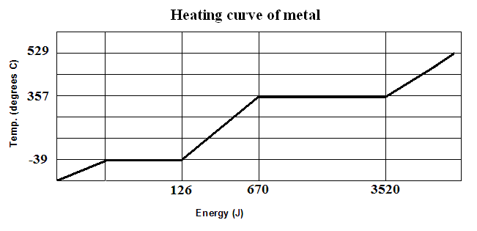
  - What is the boiling point of the metal? (1 mark) 357 ⁰C
  - What is the latent heat of vaporisation of the metal? (2 marks)

Latent heat; Q = mL
3520 – 670 = 0.01 x L
2850 = 0.01 x L
L = 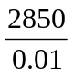
L = 285000

Latent heat of vaporisation = 2.85 x 10⁵ J kg⁻¹

- In a refrigerator, a pump is continually causing 100 g of liquid freon to evaporate then condense for every stroke is makes. The evaporation takes place inside the refrigerator and the condensation outside, so that heat is continually being extracted from the refrigerator cabinet. If the latent heat of vaporization of the liquid is 2.50 x 10⁵ Jkg⁻¹ and the pump makes 75 strokes per minute, calculate (assuming no temperature change of either the liquid freon or the gas) the amount of heat energy extracted by each stroke of the pump. (2 marks)

Once you get around all the surplus information, this is simply a latent heat problem

Q = 0.100 x 2.50 x 10⁵
= 25000

Q = 2.50 x 10⁴ J

